 DRIVE UNMATCHED BENEFITS

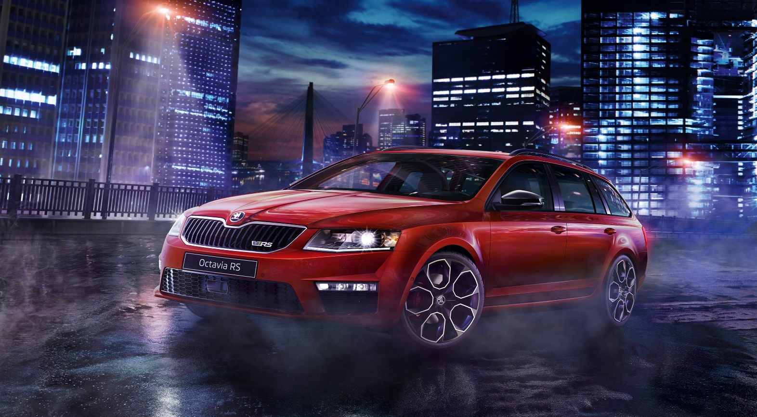

 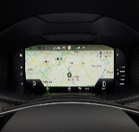 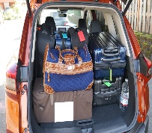 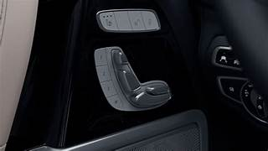

POWERFUL 25.4CM luggage bags luguxiriours

1.5 TSI ENGINE SKODA INFOTAINMENT 5.6 inch . long car

EFFICIENT s RELIABLE WITH SUBWOOFER by 1 get 1 free full in joy

made by neema